Arithmetic Reasoning and Analytical Thinking

25 minutes

Directions for questions 1-5: The following Pie Chart gives the % distribution of the Total Expense of a Family under various heads in the month of August.
Savings = Income – Expenditure.
The Income of the Family for the Month of August is Rs.50,000/-.
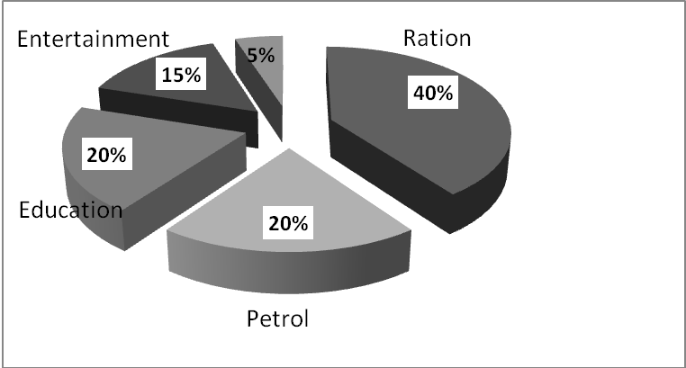
Misc

Q1: If the family saves 30% of it’s income in the month of August, then find the total expense on Petrol in the month of August?
a. 3500 b. 7000 c. 10000 d. 8000

Q2: If the total expenses on Education and Misc. heads in the month of August is Rs.7000/-, then find the savings of the family in the month of August?
a. Rs.25,000 b. Rs.30000 c. Rs.15000 d. Rs.22000

Q3: What is the central angle contributed by entertainment?
a. 72 deg. b. 90 deg. c. 120 deg. d. 54 deg.

Q4: If the family saves an amount of Rs.12000 in the month of August, then find the ratio of the expenses on Entertainment to the expense on Petrol?
a. 3:4 b. 5:6 c. 7:5 d. 4:3

Q5: If the total expense in the month of August is Rs.40,000, find the expense due to Entertainment?
a. 8000 b. 6000 c. 7000 d. none of these
Directions for questions 6-10: In each of the following questions, a question stem is followed by 2 different statements. You need to decide whether the statements given are sufficient to answer the question asked. Mark your answer option as
a. If the question can be answered by using any one of the 2 statements alone but not by the other alone.
b. If the question can be answered by using either of the 2 statements alone.
c. If the question can be answered by using the 2 statements together.
d. If the question cannot be answered by using the given statements.
Q6: What is the value of x if it is a natural number less than 100?
I. x is the square of a natural number.
II. x is the cube of a natural number.

Q7: In how much time can B alone complete the work?
I. A alone can do the work in 15 days.
II. A and B can do the work in 8 days.

Q8: How is A related to B?
I. A is the wife of the brother of B’s daughter.
II. A is the sister of B’s father.

Q9: In what ratio should the two solutions be mixed in order to get a solution having milk and water in the ratio 2:1?
I. The first solution has milk and water in the ratio 1:3.
II. The quantity of the second solution is 45 litres.

Q10: Who is the eldest among A,B and C?
I. C is younger than only A.
II. B is elder than C.

Directions for Questions 11 to 15: In each question below, there are two statements followed by two conclusions numbered 1 and 2. You need to decide which of the given conclusions logically follows from the statements given. Mark your answer as
- If only conclusion I follows
- If only conclusion II follows
- If neither I nor II follows
- If both I and II follow
Q11: Statement I: All poets are readers. Statement II: No reader is wise.
Conclusion I : No Poet is wise Conclusion II: All readers are poet.

Q12: Statement I: Some chairs are stools. Statement II: Table is a chair.
Conclusion I : Some stools are chairs Conclusion II: Table is not a stool.

Q13: Statement I: Some trees are small. Statement II: All small are plants.
Conclusion I : All plants are small. Conclusion II: Some trees are plants.

Q14: Statement I: All singers are poets. Statement II: Some authors are not singers.
Conclusion I : No poet is author. Conclusion II: Some authors are not poets.

Q15: Statement I: Some dogs are rats. Statement II: some rats are lions.
Conclusion I : Some dogs are lions. Conclusion II: None of the dogs is a lion.

Critical Thinking and Logical Reasoning

35 minutes

Q1: The letters of the word “LETTER” are to be arranged. In how many different ways can this be done such that all the vowels are together?
a. 150 ways b. 240 ways c. 60 ways d. 120 ways

Q2: A log of wood floating downstream is able to cover 5 km in 2 hours while a boat can travel 15 km in 3 hours while travelling upstream. Find the speed of the boat in still water?
a. 5 kmph b. 2.5 kmph c. 7.5 kmph d. none of these

Q3: A and B can do a work in 30 days while B and C can do it in 45 days. If A working alone can do half the work in 30 days, in how many days can C working alone finish the work?
a. 180 days b. 120 days c. 150 days d. none of these

Q4: How many 4 digit even numbers greater than 2000 can be formed using the digits 0 to 8 without repetition?
a. 1260 b. 1070 c. 1222 d. 1302

Q5: A 2:3 solution of Milk and Water is mixed with a 4:1 solution in the ratio 3:2. Find the ratio of Milk to Water in the resultant mixture?
a. 14:25 b. 14:11 c. 11:25 d. 25:11

Q6: If COUNT – COIN = SNUB then find the sum of C+O+U+N+T?
a. 13 b. 14 c. 15 d. 16

Direction for questions 7-10: 5 friends Amit, Vikas, Sanjay, Shashwat and Rajesh travelled from 5 different cities Singapore, Pune, Bangalore, Noida and Chandigarh for their reunion at Nainital. They travelled by Jet airways, Indigo, Spicejet, Air India and Go air not in any order.
Further information is as follows:
1. The person who travelled by Go air is either from Pune or Bangalore.
2. Vikas is from Singapore.
3. Rajesh travelled by Air India and is not from Chandigarh.
4. Amit travelled from Pune using Jet airways.
5. Sanjay does not travel by Go air.
6. Spicejet does not have a flight operating to or from Singapore.

Q7: Which airlines does Vikas use?
a. Jet airways b. Go air c. Indigo d. Air India

Q8: From which city did Shashwat travel for the reunion?
a. Chandigarh b. Bangalore c. Noida d. Singapore

Q9: Who travelled by Spicejet for the reunion?
a. Rajesh b. Shashwat c. Vikas d. Sanjay

Q10: The person who used Air India travelled from which city?
a. Noida b. Bangalore c. Pune d. Chandigarh

